**Defect Report**

* **Defect Id: 9**
* **Status: Closed**
* **Reported by: Bishoy**
* **Asserted to: Malek**
* **Date:**  **13/5/2023**
* **Defect description: after entering the student id = "abcdefgh", an** *INVALID_STUDENT_ID_ALPHANUMERIC* **exception must be thrown but nothing was thrown, and the student id was stored normally. The student id must contain at least 7 numbers.**
* **Steps:**

1. **Open the application**
2. **Enter the student id = "abcdefgh"**
3. **Run the program**

* **Severity: Low**
* **Priority: High**
* **Date Closed: 14/5/2023**
* **Fixed By: Malek**
* **Screenshot for the Defect:**

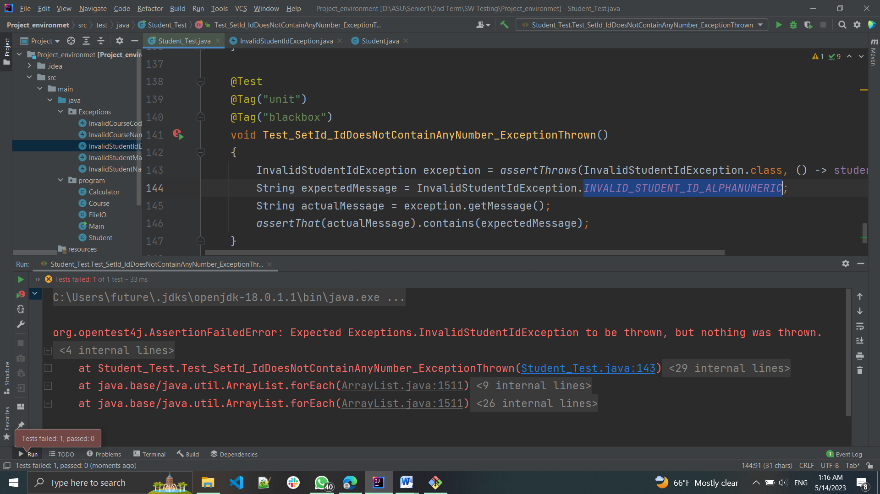

* **Screenshot after fixing:**

* **Notes from Dev team:**

**"abcdefgh" was fixed to through** "Student id must start with numbers"

*INVALID_STUDENT_ID_ALPHANUMERIC was for the last char only to enter a number or an alphabet only not a symbol like ‘@’*

*So the test case should be updated to enter* "1bcdefgh"

And should expect ***INVALID_STUDENT_ID_GENERAL***